***This is a bonus Web chapter

CHAPTER 49

Java 2D

Objectives

- To obtain a Graphics2D object for rendering Java 2D shapes (§49.2).
- To use geometric models to separate modeling of shapes from rendering (§49.3).
- To know the hierarchy of shapes (§49.3).
- To model lines, rectangles, ellipses, arcs using Line2D, Rectangle2D, RoundRectangle2D, Ellipse2D, and Arc2D (§49.4).
- To perform coordinate transformation using the translate, rotate, and scale methods (§49.5).
- To specify the attributes of lines using the BasicStroke class (§49.6).
- To define a varying color using GradientPaint and define an image paint using TexturePaint (§49.7).
- To model quadratic curves and cubic curves using the QuadCurve2D and CubicCurve2D classes (§49.8).
- To model an arbitrary geometric path using Path2D and to define interior points using the WIND_EVEN_ODD and WIND_NON_ZERO rules (§49.9).
- To perform constructive area geometry using the Area class (§49.10).

49.1 Introduction

Using the methods in the Graphics class, you learned how to draw lines, rectangles, ovals, arcs, and polygons. This chapter introduces Java 2D, which enables you to draw advanced and complex two-dimensional graphics.
NOTE:
This chapter introduces the basic and commonly used features in Java 2D. For a complete coverage of Java 2D, please see Computer Graphics Using Java 2D and 3D by Hong Zhang and Y. Daniel Liang, published by Prentice Hall.
49.2 Obtaining a Graphics2D Object
You used the drawing methods in the Graphics class in the text. The Graphics class is primitive. The Java 2D API provides the java.awt.Graphics2D class, which extends java.awt.Graphics with advanced capabilities for rendering graphics. Normally, you write the code to draw graphics in the paintComponent method in a GUI component. The coding template for the method is as follows:
protected void paintComponent(Graphics g) {
super.paintComponent(g);

// Use the method in Graphics to draw graphics
...
}

The parameter passed to the paintComponent method is actually an instance of Graphics2D. So, to obtain a Graphics2D reference, you may simply cast the parameter g to Graphics2D as follows:
protected void paintComponent(Graphics g) {
super.paintComponent(g);

Graphics2D g2d = (Graphics2D)g; // Get a Graphics2D object

// Use the method in Graphics2D to draw graphics
...
}

Since Graphics2D is a subclass of Graphics, all the methods in Graphics can be used in Graphics2D. Additionally, you can use the methods in Graphics2D.
49.3 Geometric Models
You have used the methods in the Graphics class to draw lines, rectangles, arcs, ellipses, and polygons. The Java 2D API uses the model-view controller architecture to separate rendering from modeling. This approach enables you to create shapes and perform manipulations, such as transforming and rotating, to combine shapes using models, and to use Graphics2D to render shapes.
Java 2D provides facilities to construct basic shapes and to combine them to form more complex shapes. Figure 49.1 shows various shapes supported in Java 2D.
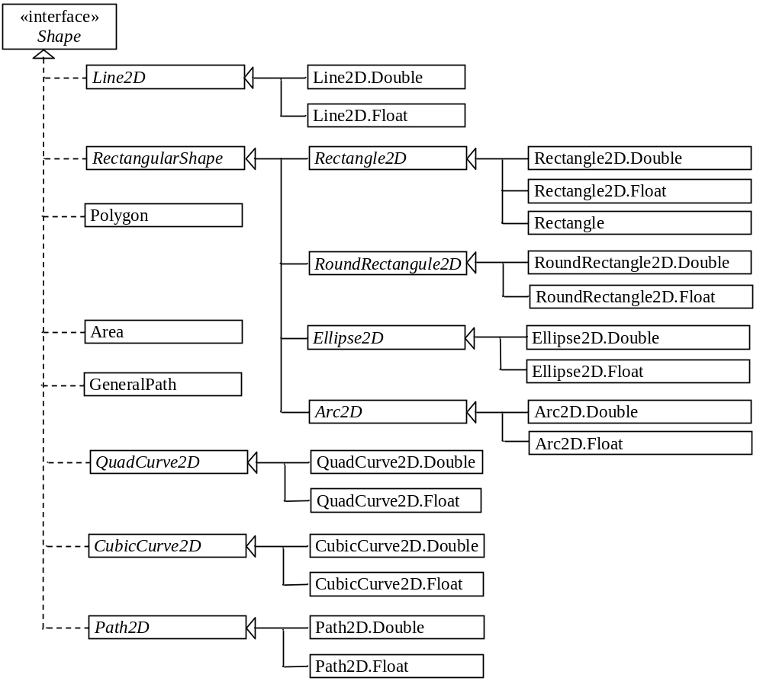
Figure 49.1
Java 2D defines various shapes.
<Side remark: methods in Shape>
The Shape interface defines the common features for shapes and provides the contains method to test whether a point or a rectangle is inside a shape, and the intersects method to test whether the shape overlaps with a rectangle, as shown in Figure 49.2. These methods are often useful in geometrical programming.
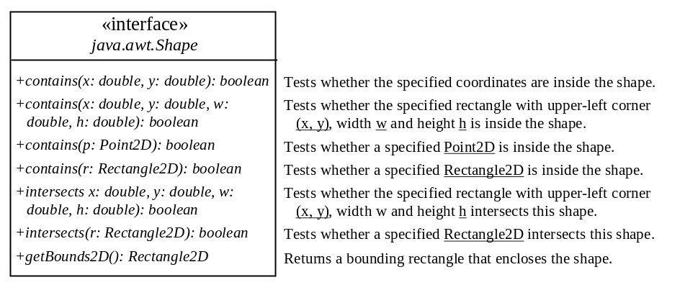
Figure 49.2
Shape is the root interface for all Java 2D shapes.
<Side remark: concrete shape classes>
Classes Line2D, Rectangle2D, RoundRectangle2D, Arc2D, Ellipse2D, QuadCurve2D, CubicCurve2D, and Path2D are abstract classes. Each contains two concrete static inner classes named Double and Float for double and float coordinates, respectively. For example, Line2D.Double refers to the static inner class Double defined in the Line2D class. You can use either Line2D.Double or Line2D.Float to create an object for modeling a line, depending on whether you want to use double or float for coordinates. These inner classes are also subclasses of their respective outer classes. So Line2D.Double is a subclass of Line2D.

<Side remark: Point2D>
A point can be modeled using the abstract Point2D class. It contains two concrete static inner classes Point2D.Double and Point2D.Float for double and float coordinates, respectively. Point2D.Double and Point2D.Float are also subclasses of Point2D. The Point class was introduced in JDK 1.1 and now is included in Java 2D for backward compatibility. Point is now defined as a subclass of Point2D. Point2D contains the methods for finding the distance between two points.

<Side remark: create a shape>
To create a shape, use the constructor of a concrete shape class. For example, to model a line from (x1, y1) to (x2, y2), you may create a Line2D object with double data type using the following constructor:

<Side remark: create a line>
Line2D line = new Line2D.Double(x1, y1, x2, y2);

The Graphics2D class contains the draw(Shape s) method to draw the boundary of the shape and the fill(Shape s) method to fill the interior of the shape. To render the line on a GUI component, use

<Side remark: render a line>
g2d.draw(line);

where g2d is a Graphics2D object for the GUI component.

49.4 Rectangle2D, RoundRectangle2D, Arc2D, and Ellipse2D
<Side remark: RectangularShape>
RectangularShape is an abstract base class for Rectangle2D, RoundRectangle2D, Arc2D, and Ellipse2D, whose geometry is defined by a rectangular frame. Figure 49.3 shows the UML diagram for RectangularShape.
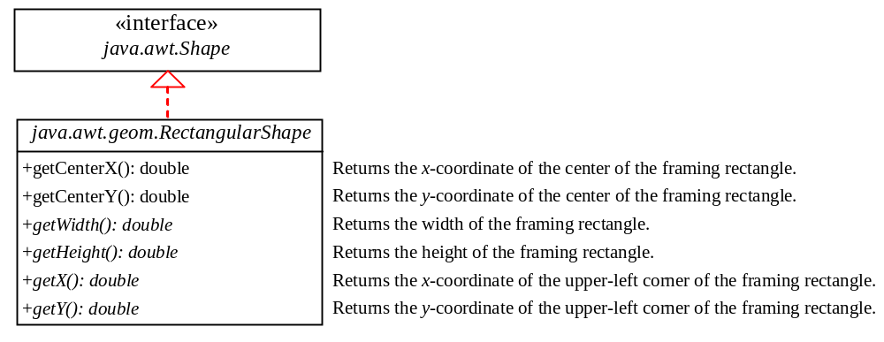
Figure 49.3
RectangularShape defines a shape with a bounding rectangle.
<Side remark: Rectangle2D>
Rectangle2D models a rectangle with horizontal and vertical sides. The Rectangle class was introduced in JDK 1.1 and now is included in Java 2D for backward compatibility. Rectangle is now defined as a subclass of Rectangle2D. It models a rectangle with integer coordinates, while Rectangle2D.Double and Rectangle2D.Float model a rectangle with double and float coordinates, respectively. You can construct a Rectangle using

new Rectangle(x, y, w, h)

The parameters x and y represent the upper-left corner of the rectangle, and w and h are its width and height (see Figure 49.4a).
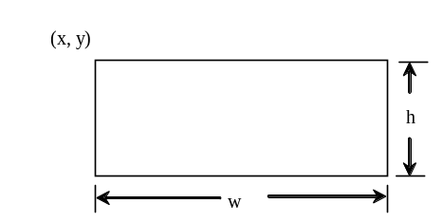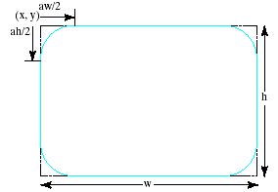

(a) Rectangle (b) Round rectangle
Figure 49.4
- A rectangle is defined in four parameters. (b) A round rectangle is defined in six parameters.
The following code creates three Rectangle2D objects with integer, double, and float coordinates, respectively. The upper-left corner of the rectangle is at (20, 40) with width 100 and height 200.

Rectangle2D ri = new Rectangle(20, 40, 100, 200);
Rectangle2D rd = new Rectangle.Double(20D, 40D, 100D, 200D);
Rectangle2D rf = new Rectangle.Double(20F, 40F, 100F, 200F);

<Side remark: RoundRectangle2D>
RoundRectangle2D models a rectangle with round corners. You can construct a RoundRectangle using

new RoundRectangle2D.Double(x, y, w, h, aw, ah)

Parameters x, y, w, and h specify a rectangle, parameter aw is the horizontal diameter of the arcs at the corner, and ah is the vertical diameter of the arcs at the corner (see Figure 49.4(b)). In other words, aw and ah are the width and the height of the oval that produces a quarter-circle at each corner.

<Side remark: Ellipse2D>
Ellipse2D models an ellipse. You can construct an Ellipse2D using

new Ellipse2D.Double(x, y, w, h)

Parameters x, y, w and h specify the bounding rectangle for the ellipse, as shown in Figure 49.5a.

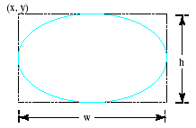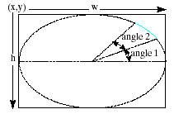
(a) Ellipse (b) Arc
Figure 49.5
An ellipse or oval is defined by its bounding rectangle.
<Side remark: Arc2D>
Arc2D models an elliptic arc. You can construct an Arc2D using

new Arc2D.Double(x, y, w, h, startAngle, arcAngle, type)

Parameters x, y, w and h specify the bounding rectangle for the arc; parameter startAngle is the starting angle; arcAngle is the spanning angle (i.e., the angle covered by the arc). Angles are measured in degrees and follow the usual mathematical conventions (i.e., 0 degrees is in the easterly direction, and positive angles indicate counterclockwise rotation from the easterly direction); see Figure 49.5(b).

Parameter type is Arc2D.OPEN, Arc2D.CHORD, or Arc2D.PIE. Arc2D.OPEN specifies that the arc is open. Arc2D.CHORD specifies that the arc is connected by drawing a line segment from the start the arc to the end of the arc. Arc2D.PIE specifies that the arc is connected by drawing straight line segments from the start of the arc segment to the center of the full ellipse and from that point to the end of the arc segment.

Listing 49.1 gives a program that demonstrates how to draw various shapes using Graphics2D. Figure 49.6 shows a sample run of the program.

Listing 49.1 Graphics2DDemo.java
<Side remark: Line 2: import for shape classes>
<Side remark: Line 5: applet>
<Side remark: Line 14: Graphics2D reference>
<Side remark: Line 16: draw a line>
<Side remark: Line 17: draw a rectangle>
<Side remark: Line 18: fill a rectangle>
<Side remark: Line 19: round rectangle>
<Side remark: Line 20: draw an ellipse>
<Side remark: Line 21: draw an arc>
<Side remark: Line 28: main method omitted>
import java.awt.*;
import java.awt.geom.*;
import javax.swing.*;

public class Graphics2DDemo extends JApplet {
public Graphics2DDemo() {
add(new ShapePanel());
}

static class ShapePanel extends JPanel {
protected void paintComponent(Graphics g) {
super.paintComponent(g);

Graphics2D g2d = (Graphics2D)g;

g2d.draw(new Line2D.Double(10, 10, 40, 80));
g2d.draw(new Rectangle2D.Double(50, 10, 30, 70));
g2d.fill(new Rectangle2D.Double(90, 10, 30, 70));
g2d.fill(new RoundRectangle2D.Double(130, 10, 30, 70, 20, 30));
g2d.draw(new Ellipse2D.Double(170, 10, 30, 70));
g2d.draw(
new Arc2D.Double(220, 10, 30, 70, 0, 270, Arc2D.OPEN));
g2d.draw(new Arc2D.Double(260, 10, 30, 70, 0, 270, Arc2D.PIE));
g2d.draw(
new Arc2D.Double(300, 10, 30, 70, 0, 270, Arc2D.CHORD));
}
}
}

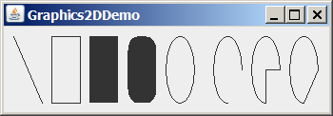
Figure 49.6
You can draw various shapes using Java 2D.
The shape classes Line2D, Rectangle2D, RoundRectangle2D, Arc2D, and Ellipse2D are in the java.awt.geom package. So, they are imported in line 2.
<Side remark: Line2D>
A Graphics2D reference is obtained in line 14 in order to invoke the methods in Graphics2D. The statement new Line2D.Double(10, 10, 40, 80) (line 16) creates an instance of Line2D.Double, which is also an instance of Line2D and Shape. The instance models a line from (10, 10) to (40, 80).
<Side remark: Rectangle2D>
The statement new Rectangle2D.Double(50, 10, 30, 70) (line 17) creates an instance of Rectangle2D.Double, which is also an instance of Rectangle2D and Shape. The instance models a rectangle whose upper-left corner point is (50, 10) with width 30 and height 70.
<Side remark: fill>
The fill(Shape) method (line 18) renders a filled rectangle.
<Side remark: RoundRectangle2D>
The statement new RoundRectangle2D.Double(130, 10, 30, 70, 20, 30) (line 19) creates an instance of RoundRectangle2D.Double, which is also an instance of RoundRectangle2D and Shape. The instance models a round-cornered rectangle whose parameters are the same as in the drawRoundRect(int x, int y, int w, int h, int aw, int ah) method in the Graphics class.
<Side remark: Ellipse2D>
The statement new Ellipse2D.Double(300, 10, 30, 70) (line 20) creates an instance of Ellipse2D.Double, which is also an instance of Ellipse2D and Shape. The instance models an ellipse. The parameters in this constructor are the same as the parameters in the drawOval(int x, int y, int w, int h) method in the Graphics class.
<Side remark: Arc2D>
The statement new Arc2D.Double(170, 10, 30, 70, 0, 270, Arc2D.OPEN) (line 21) creates an instance of Arc2D.Double, which is also an instance of Arc2D and Shape. The instance models an open arc. The parameters in this constructor are similar to the parameters in the drawArc(int x, int y, int w, int h, int startAngle, int arcAngle) method in the Graphics class, except that the last parameter specifies whether the arc is open or closed. The value Arc2D.OPEN specifies that the arc is open. The value Arc2D.PIE (line 23) specifies that the arc is closed by drawing straight line segments from the start of the arc segment to the center of the full ellipse and from that point to the end of the arc segment. The value Arc2D.CHORD (line 25) specifies that the arc is closed by drawing a straight line segment from the start of the arc segment to the end of the arc segment.
49.5 Coordinate Transformations
Java 2D provides the classes for modeling geometric objects. It also supports coordinate transformations using translation, rotation, and scaling.
49.5.1 Translations
You can use the translate(double x, double y) method in the Graphics class to move the subsequent rendering by the specified distance relative to the previous position. For example, translate(5, -10) moves subsequent rendering 5 pixels to the right and 10 pixels up from the previous position, and translate(-5, 10) moves all shapes 5 pixels to the left and 10 pixels down from the previous position. Figure 49.7 shows a rectangle displayed before and after applying translation. After invoking g2d.translate(-6, 4), the rectangle is displayed 6 pixels to the left and 4 pixels down from the previous position.
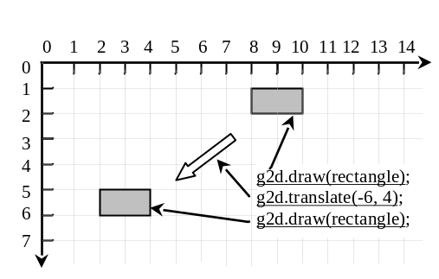
Figure 49.7
(a) After applying g2d.translate(-6, 4), the subsequent rendering of the rectangle is moved by the specified distance relative to the previous position.
Listing 49.2 gives a program that demonstrates the effect of translation of coordinates. Figure 49.8 shows a sample run of the program.
Listing 49.2 TranslationDemo.java
<Side remark: Line 2: import for shape classes>
<Side remark: Line 5: applet>
<Side remark: Line 14: Graphics2D reference>
<Side remark: Line 15: a rectangle>
<Side remark: Line 17: random number>
<Side remark: Line 19: set a new color>
<Side remark: Line 21: display rectangle>
<Side remark: Line 22: translate>
<Side remark: Line 26: main method omitted>
import java.awt.*;
import java.awt.geom.*;
import javax.swing.*;

public class TranslateDemo extends JApplet {
public TranslateDemo() {
add(new ShapePanel());
}

class ShapePanel extends JPanel {
protected void paintComponent(Graphics g) {
super.paintComponent(g);

Graphics2D g2d = (Graphics2D)g;
Rectangle2D rectangle = new Rectangle2D.Double(10, 10, 50, 60);

java.util.Random random = new java.util.Random();
for (int i = 0; i < 10; i++) {
g2d.setColor(new Color(random.nextInt(256),
random.nextInt(256), random.nextInt(256)));
g2d.draw(rectangle);
g2d.translate(20, 5);
}
}
}

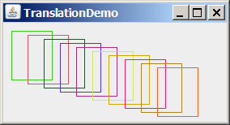
Figure 49.8
The rectangles are displayed successively in new locations.
Line 17 creates a Random object. The Random class was introduced in §8.6.2, “The Random Class.” Invoking random.nextInt(256) (line 19) returns a random int value between 0 and 255. The setColor method (line 19) sets a new color for subsequent rendering. Line 21 draws a rectangle. The translate(20, 5) method in line 22 moves the subsequent rendering 20 pixels to the right and 5 pixels down.
49.5.2 Rotations
You can use the rotate(double theta) method in the Graphics2D class to rotate subsequent rendering by theta degrees from the origin clockwise, where theta is a double value in radians. By default the origin is (0, 0). You can use the translate(x, y) method to move the origin to a specified location. For example, rotate(Math.PI / 4) rotates subsequent rendering 45 degrees counterclockwise along the northern direction from the origin, as shown in Figure 49.9.
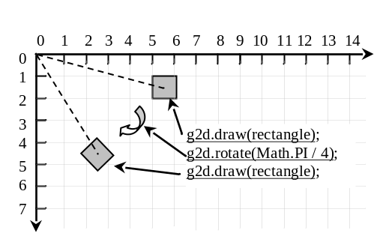
Figure 49.9
After performing g2d.rotate(Math.PI / 4), the rectangle is rotated in 45 degrees from the origin.
Listing 49.3 gives a program that demonstrates the effect of rotation of coordinates. Figure 49.10 shows a sample run of the program.
Listing 49.3 RotationDemo.java
<Side remark: Line 2: import for shape classes>
<Side remark: Line 5: applet>
<Side remark: Line 14: Graphics2D reference>
<Side remark: Line 15: a rectangle>
<Side remark: Line 17: new origin>
<Side remark: Line 18: draw center point>
<Side remark: Line 19: random number>
<Side remark: Line 21: set a new color>
<Side remark: Line 23: display rectangle>
<Side remark: Line 24: rotate>
<Side remark: Line 28: main method omitted>
import java.awt.*;
import java.awt.geom.*;
import javax.swing.*;

public class RotationDemo extends JApplet {
public RotationDemo() {
add(new ShapePanel());
}

class ShapePanel extends JPanel {
protected void paintComponent(Graphics g) {
super.paintComponent(g);

Graphics2D g2d = (Graphics2D)g;
Rectangle2D rectangle = new Rectangle2D.Double(20, 20, 50, 60);

g2d.translate(150, 120); // Move origin to the center
g2d.fill(new Ellipse2D.Double(-5, -5, 10, 10));
java.util.Random random = new java.util.Random();
for (int i = 0; i < 10; i++) {
g2d.setColor(new Color(random.nextInt(256),
random.nextInt(256), random.nextInt(256)));
g2d.draw(rectangle);
g2d.rotate(Math.PI / 5);
}
}
}
}

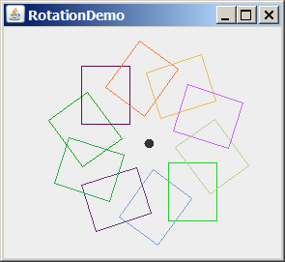
This rectangle is drawn first
This rectangle is drawn next
Figure 49.10
After the rotate method is invoked, the rectangles are displayed successively in new locations.
The translate(150, 120) method moves the origin from (0, 0) to (150, 120) (line 17). The loop is repeated ten times. Each iteration sets a new color randomly (line 21), draws the rectangle (line 23), and rotates 36 degrees from the new origin (line 24).
49.5.3 Scaling
You can use the scale(double sx, double sy) method in the Graphics2D class to resize subsequent rendering by the specified scaling factors. For example, scale(2, 2) resizes the object by doubling the x- and y-coordinates in the object, as shown in Figure 49.11.
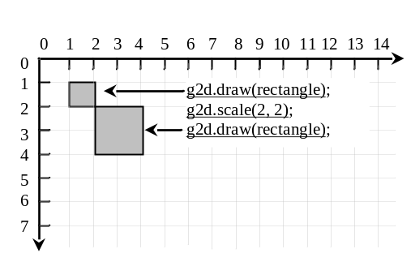
Figure 49.11
After performing g2d.scale(2, 2), the x- and y-coordinates in the original rectangle are doubled.
Listing 49.4 gives a program that demonstrates the effect of using scaling. Figure 49.12 shows a sample run of the program.
Listing 49.4 ScalingDemo.java
<Side remark: Line 2: import for shape classes>
<Side remark: Line 5: applet>
<Side remark: Line 14: Graphics2D reference>
<Side remark: Line 15: a rectangle>
<Side remark: Line 18: display rectangle>
<Side remark: Line 19: scale>
<Side remark: Line 23: main method omitted>
import java.awt.*;
import java.awt.geom.*;
import javax.swing.*;

public class ScalingDemo extends JApplet {
public ScalingDemo() {
add(new ShapePanel());
}

class ShapePanel extends JPanel {
protected void paintComponent(Graphics g) {
super.paintComponent(g);

Graphics2D g2d = (Graphics2D)g;
Rectangle2D rectangle = new Rectangle2D.Double(10, 10, 10, 10);

for (int i = 0; i < 4; i++) {
g2d.draw(rectangle);
g2d.scale(2, 2);
}
}
}
}

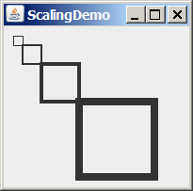
Figure 49.12
After scaling is applied, the rectangles are displayed successively.
The program draws four rectangles. The upper-left corner of the first rectangle is at (10, 10). After invoking scale(2, 2) (line 19) on the Graphics2D object g2d in the first iteration of the loop, the upper-left corner of the second rectangle is at (20, 20), since this scale method causes the coordinates in the current object to be doubled. After invoking scale(2, 2) (line 19) on the Graphics2D object g2d in the second iteration of the loop, the upper-left corner of the third rectangle is at (40, 40). After invoking scale(2, 2) (line 19) on the Graphics2D object g2d in the third iteration of the loop, the upper-left corner of the fourth rectangle is at (80, 80).
It is interesting to note that the thickness of line segments also doubles each time scale(2, 2) is invoked. We will discuss the thickness of lines in the next section.
49.6 Strokes
Java 2D allows you to specify the attributes of lines, called strokes. You can specify the width of the line, how the line ends (called end caps), how lines join together (called line joins), and whether the line is dashed. These attributes are defined in a Stroke object. You can create a Stroke object using the BasicStroke class, as shown in Figure 49.13.
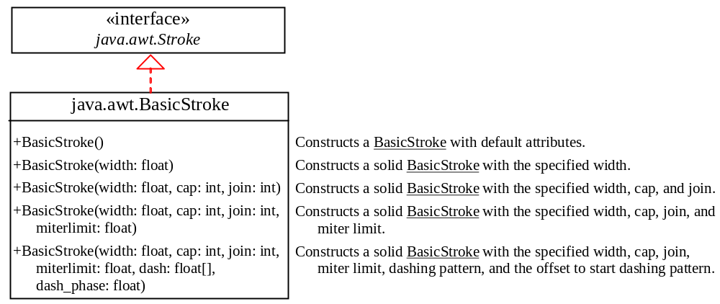
Figure 49.13
You can create a Stroke using the BasicStroke class.
The parameter width specifies the thickness of the stroke with a default value 1.0.
The parameter cap is one of three values:
- BasicStroke.CAP_ROUND for round cap.
- BasicStroke.CAP_SQUARE for square cap.
- BasicStroke.CAP_BUTT for no added decorations.
The parameter join is one of three values:
- BasicStroke.JOIN_BEVEL for joining the outer corners of their wide outlines with a straight segment.
- BasicStroke.JOIN_MITER for joining path segments by extending their outside edges until they meet.
- BasicStroke.JOIN_ROUND for joining path segments by rounding off the corner at a radius of half the line width.

The parameter miterlimit sets a limit for JOIN_MITER to prevent a very long join when the angle between the two lines is small.
The parameter dash array defines a dash pattern by alternating between opaque and transparent sections. The dash_phase parameter specifies the offset to start the dashing pattern.
To set a stroke in Graphics2D, use
void setStroke(Stroke stroke)

Listing 49.5 gives a program that demonstrates the effect of using basic strokes. Figure 49.14 shows a sample run of the program.
Listing 49.5 BasicStrokeDemo.java
<Side remark: Line 2: import for shape classes>
<Side remark: Line 5: applet>
<Side remark: Line 14: Graphics2D reference>
<Side remark: Line 16: set a stroke>
<Side remark: Line 18: draw a line>
<Side remark: Line 20: translate>
<Side remark: Line 31: draw a rectangle>
<Side remark: Line 49: main method omitted>
import java.awt.*;
import java.awt.geom.*;
import javax.swing.*;

public class BasicStrokeDemo extends JApplet {
public BasicStrokeDemo() {
add(new ShapePanel());
}

class ShapePanel extends JPanel {
protected void paintComponent(Graphics g) {
super.paintComponent(g);

Graphics2D g2d = (Graphics2D)g;

g2d.setStroke(new BasicStroke(15.0f, BasicStroke.CAP_ROUND,
BasicStroke.JOIN_BEVEL));
g2d.draw(new Line2D.Double(10, 10, 40, 80));

g2d.translate(100, 0);
g2d.setStroke(new BasicStroke(15.0f, BasicStroke.CAP_SQUARE,
BasicStroke.JOIN_BEVEL));
g2d.draw(new Line2D.Double(10, 10, 40, 80));

g2d.translate(100, 0);
g2d.setStroke(new BasicStroke(15.0f, BasicStroke.CAP_BUTT,
BasicStroke.JOIN_BEVEL));
g2d.draw(new Line2D.Double(10, 10, 40, 80));

g2d.translate(100, 0);
g2d.draw(new Rectangle2D.Double(10, 10, 30, 70));

g2d.translate(100, 0);
g2d.setStroke(new BasicStroke(15.0f, BasicStroke.CAP_ROUND,
BasicStroke.JOIN_MITER));
g2d.draw(new Rectangle2D.Double(10, 10, 30, 70));

g2d.translate(100, 0);
g2d.setStroke(new BasicStroke(15.0f, BasicStroke.CAP_SQUARE,
BasicStroke.JOIN_ROUND));
g2d.draw(new Rectangle2D.Double(10, 10, 30, 70));

g2d.translate(100, 0);
g2d.setStroke(new BasicStroke(4.0f, BasicStroke.CAP_SQUARE,
BasicStroke.JOIN_ROUND, 1.0f, new float[]{8}, 0));
g2d.draw(new Line2D.Double(10, 10, 40, 80));
}
}
}

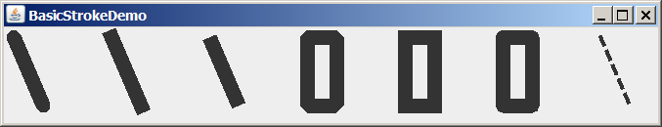
butt cap
round join cap
dash line
round cap
square cap
bevel join cap
miter join cap
Figure 49.14
You can specify the attributes for strokes.
The statement new BasicStroke(15.0f, BasicStroke.CAP_ROUND, BasicStroke.JOIN_BEVEL) (line 16) creates an instance of BasicStroke, which is also an instance of the Stroke interface. The setStroke(Stroke) method sets a Stroke object for the Graphics2D context. The program sets new Stroke objects in lines 21, 26, 34, 39, 49. Line 44 sets a new Stroke object with width 4.0f, round square cap, round join, miter limit 1.0, dashing pattern {8}, and dash phase 0.
49.7 Paint
You can use the setColor(Color c) method in the Graphics class to set a color. It sets only a solid color. Graphics2D provides the setPaint(Paint p) method to set a paint. Paint is a generalization of color. It can represent more attributes than simple solid colors.
Paint is an interface for three concrete classes including Color, as shown in Figure 49.15.
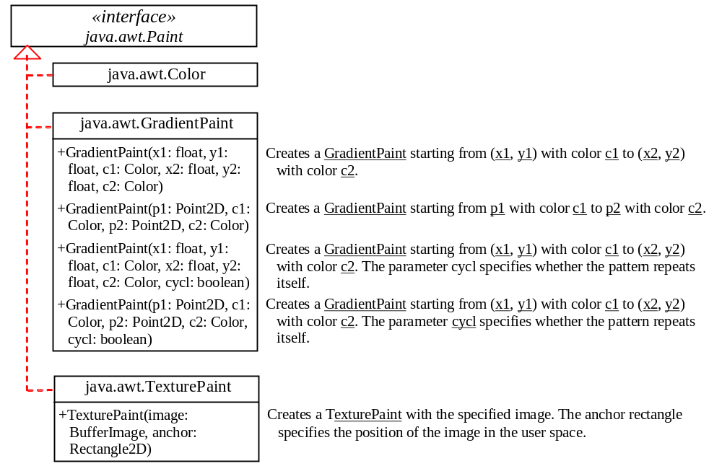
Figure 49.15
A Paint object specifies colors.
GradientPaint defines a varying color, specified by two points and two colors. As the location moves from the first point to the second, the paint changes gradually from the first color to the second. A GradientPaint can be cyclic or acyclic. A cyclic paint repeats the same pattern periodically.
TexturePaint defines an image to fill a shape or characters. The parameter image is specified as a BufferedImage. The anchor parameter specifies a rectangle on which the image is anchored. The image is repeated around the anchor rectangle, as shown in Figure 49.16.
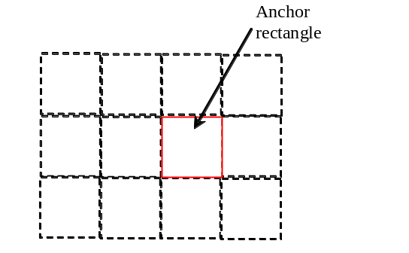
Figure 49.16
A TexturePaint is specified by an image in an anchor rectangle.
Listing 49.6 gives a program that demonstrates the effect of using GradientPaint and TexturePaint. Figure 49.17 shows a sample run of the program.
Listing 49.6 PaintDemo.java
<Side remark: Line 17: GradientPaint>
<Side remark: Line 29: solid color>
<Side remark: Line 35: get URL>
<Side remark: Line 36: TexturePaint>
<Side remark: Line 39: set paint>
<Side remark: Line 60: main method>

import java.awt.*;
import java.awt.geom.*;
import javax.imageio.ImageIO;
import javax.swing.*;

public class PaintDemo extends JApplet {
public PaintDemo() {
add(new ShapePanel());
}

class ShapePanel extends JPanel {
protected void paintComponent(Graphics g) {
super.paintComponent(g);

Graphics2D g2d = (Graphics2D)g;

g2d.setPaint(new GradientPaint(10, 10, Color.RED, 40, 40,
Color.BLUE, true));
g2d.fill(new Rectangle2D.Double(10, 10, 90, 70));
g2d.setFont(new Font("Serif", Font.BOLD, 50));
g2d.drawString("GradientPaint", 10, 120);

g2d.translate(100, 0);
g2d.setPaint(new GradientPaint(10, 10, Color.YELLOW, 40, 40,
Color.BLACK));
g2d.fill(new Rectangle2D.Double(10, 10, 90, 70));

g2d.translate(100, 0);
g2d.setPaint(Color.YELLOW);
g2d.fill(new Rectangle2D.Double(10, 10, 90, 70));

try {
java.net.URL url =
getClass().getClassLoader().getResource("image/ca.gif");
java.awt.image.BufferedImage image = ImageIO.read(url);
TexturePaint texturePaint = new TexturePaint(image,
new Rectangle2D.Double(10, 10, 100, 70));
g2d.translate(130, 0);
g2d.setPaint(texturePaint);
g2d.fill(new Ellipse2D.Double(10, 10, 100, 70));

texturePaint = new TexturePaint(image,
new Rectangle2D.Double(10, 10, 50, 70));
g2d.translate(110, 0);
g2d.setPaint(texturePaint);
g2d.fill(new Ellipse2D.Double(10, 10, 100, 70));

texturePaint = new TexturePaint(image,
new Rectangle2D.Double(10, 10, 50, 35));
g2d.translate(110, 0);
g2d.setPaint(texturePaint);
g2d.fill(new Ellipse2D.Double(10, 10, 100, 70));
g2d.drawString("TexturePaint", -190, 120);
}
catch (java.io.IOException ex) {
ex.printStackTrace();
}
}
}
}

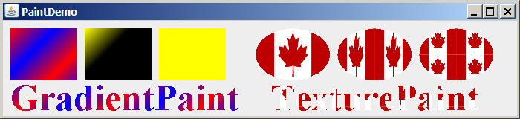
Figure 49.17
Shapes and characters are drawn with gradient paint, solid color, and texture paint.
The statement in lines 17–18
g2d.setPaint(new GradientPaint(10, 10, Color.RED, 40, 40,
Color.BLUE, true));

creates an instance of GradientPaint and sets the paint in g2d.
The program sets a new Paint object (lines 17, 24, 29) before drawing a filled rectangle (lines 19, 26, 30). Note that you can use the setPaint method to set a Color object (line 29) or use the setColor method in the Graphics class to set a color.
As you see in Figure 49.17, the gradient colors are repeated in the first rectangle, since the GradientPaint is cyclic (lines 17–18). The gradient colors are not repeated in the second rectangle, since the GradientPaint is acyclic (lines 24–25).
To create a TexturePaint, you need to create a BufferedImage from an image file. The URL of the image file is created in lines 33–49. This subject was introduced in §18.10, “Locating Resources Using the URL Class.” You can use the static method read in the ImageIO class to obtain a BufferedImage from the URL of the image (line 35).
The statement in lines 36–37
TexturePaint texturePaint = new TexturePaint(image,
new Rectangle2D.Double(10, 10, 100, 70));

creates a TexturePaint with the image anchored in the rectangle whose upper-left corner is (10, 10) and width and height are 100 and 70. This TexturePaint object is set in g2d in line 39. Line 40 fills an ellipse with this TexturePaint, as shown in Figure 49.18a.
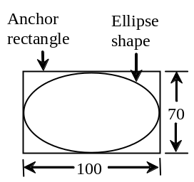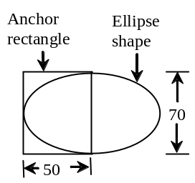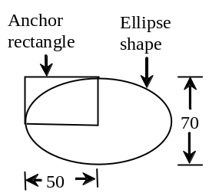
(a) (b) (c)
Figure 49.18
The anchor rectangle defines the size and position of the starting image.
The statement in lines 42-43
texturePaint = new TexturePaint(image,
new Rectangle2D.Double(10, 10, 50, 70));

creates a TexturePaint with the image anchored in the rectangle whose upper-left corner is (10, 10) and width and height are 50 and 70. This TexturePaint object is set in g2d in line 45. Line 46 fills an ellipse with this TexturePaint, as shown in Figure 49.18(b). As you see in the sample output in Figure 49.17, the texture paint is repeated from the anchor rectangle.
Line 53 displays a string. The characters are filled with the paint set in line 51.
49.8 QuadCurve2D and CubicCurve2D
Java 2D provides the QuadCurve2D and CubicCurve2D classes for modeling quadratic curves and cubic curves. QuadCurve2D.Double and QuadCurve2D.Float are two concrete subclasses of QuadCurve2D. CubicCurve2D.Double and CubicCurve2D.Float are two concrete subclasses of CubicCurve2D.
A quadratic curve is mathematically defined as a quadratic polynomial. To create a QuadCurve2D.Double, use the following constructor:
QuadCurve2D.Double(double x1, double y1,
double ctrlx, double ctrly, double x2, double y2)

where (x1, y1) and (x2, y2) specify two endpoints and (ctrlx, ctrly) is a control point. The control point is usually not on the curve instead of defining the trend of the curve, as shown in Figure 49.19a.
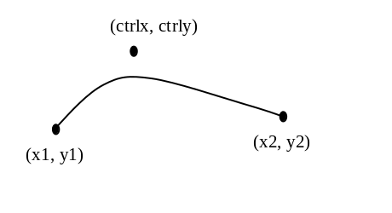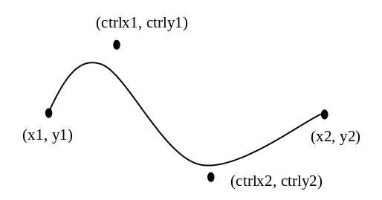
(a) (b)
Figure 49.19
(a) A quadratic curve is specified using three points. (b) A cubic curve is specified using four points.
A cubic curve is mathematically defined as a cubic polynomial. To create a CubicCurve2D.Double, use the following constructor:
CubicCurve2D.Double(double x1, double y1, double ctrlx1,
double ctrly1, double ctrlx2, double ctrly2, double x2, double y2)

where (x1, y1) and (x2, y2) specify two endpoints and (ctrlx1, ctrly1) and (ctrlx2, ctrly2) are two control points. The control points are usually not on the curve instead of defining the trend of the curve, as shown in Figure 49.19(b).
Listing 49.7 gives a program that demonstrates how to draw quadratic curves and cubic curves. Figure 49.20 shows a sample run of the program.
Listing 49.7 CurveDemo.java
<Side remark: Line 2: import for shape classes>
<Side remark: Line 5: applet>
<Side remark: Line 14: Graphics2D reference>
<Side remark: Line 17: quadratic curve>
<Side remark: Line 22: cubic curve>
<Side remark: Line 32: main method omitted>
import java.awt.*;
import java.awt.geom.*;
import javax.swing.*;

public class CurveDemo extends JApplet {
public CurveDemo() {
add(new CurvePanel());
}

static class CurvePanel extends JPanel {
protected void paintComponent(Graphics g) {
super.paintComponent(g);

Graphics2D g2d = (Graphics2D)g;

// Draw a quadratic curve
g2d.draw(new QuadCurve2D.Double(10, 80, 40, 20, 150, 56));
g2d.fillOval(40 + 3, 20 + 3, 6, 6);
g2d.drawString("Control point", 40 + 5, 20);

// Draw a cubic curve
g2d.draw(new CubicCurve2D.Double
(200, 80, 240, 20, 350, 156, 450, 80));
g2d.fillOval(240 + 3, 20 + 3, 6, 6);
g2d.drawString("Control point 1", 240 + 3, 20);
g2d.fillOval(350 + 3, 156 + 3, 6, 6);
g2d.drawString("Control point 2", 350 + 3, 156 + 3);
}
}
}

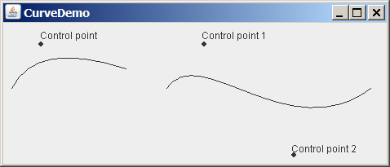
Figure 49.20
You can draw quadratic and cubic curves using Java 2D.
<Side remark: QuadCurve2D>
A Graphics2D reference is obtained in line 14 in order to invoke the methods in Graphics2D. The statement new QuadCurve2D.Double(10, 80, 40, 20, 150, 56) (line 17) creates an instance of QuadCurve2D.Double, which is also an instance of QuadCurve2D and Shape. The instance models a quadratic curves with two endpoints (10, 80), (150, 56) and a control point (40, 20).
The fillOval (line 18) and drawString (line 19) methods are defined in the Graphics class and so can be used in the Graphics2D class.
<Side remark: CubicCurve2D>
The statement new CubicCurve2D.Double(200, 80, 240, 20, 350, 156, 450, 80)) (lines 22–23) creates an instance of CubicCurve2D.Double, which is also an instance of QuadCurve2D and Shape. The instance models a quadratic curves with two endpoints (200, 80), (450, 80) and two control points (240, 20), (450, 80).
49.9 Path2D
The Path2D class models an arbitrary geometric path. Path2D.Double and Path2D.Float are two concrete subclasses of Path2D. Java 2D also contains the GeneralPath class which is now superseded by Path 2D.Float.
You can construct path segments using the methods, as shown in Figure 49.21.
<PD: UML Class Diagram>
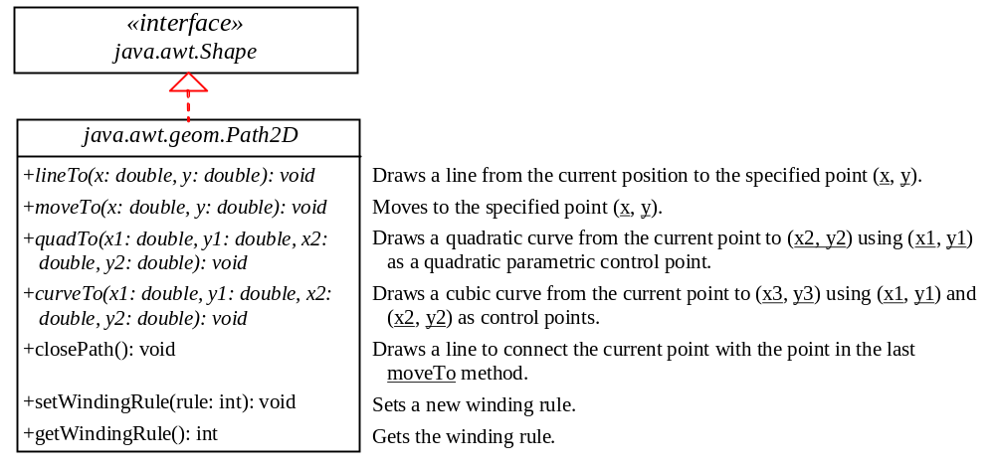
Figure 49.21
The Path2D class contains the methods for constructing path segments.
You may create a Path2D using a constructor from Path2D.Double and Path2D.Float. The process of the path construction can be viewed as drawing with a pen. At any moment, the pen has a current position. You can use the moveTo(x, y) method to move the pen to the new position at point (x, y), use the lineTo(x, y) to add a point (x, y) to the path by drawing a straight line from the current point to this new point, use the quadTo(ctrlx, ctrly, x, y) method to draw a quadratic curve from the current location to (x, y) using (ctrlx, ctrly) as the control point, use the curveTo(ctrlx1, ctrly1, ctrlx2, ctrly2, x, y) method to draw a cubic curve from the current location to (x, y) using (ctrlx1, ctrly1) and (ctrlx2, ctrly2) as the control points, and use the closePath() method to connect the current point with the point in the last moveTo method.
Listing 49.8 gives a program that demonstrates how to draw a shape using Path2D. Figure 49.22 shows a sample run of the program.
Listing 49.8 Path2DDemo.java
<Side remark: Line 2: import for shape classes>
<Side remark: Line 5: applet>
<Side remark: Line 14: Graphics2D reference>
<Side remark: Line 16: new position>
<Side remark: Line 17: draw a cubic curve>
<Side remark: Line 18: new position>
<Side remark: Line 19: draw a cubic curve>
<Side remark: Line 20: draw a line>
<Side remark: Line 21: close path>
<Side remark: Line 23: display path>
<Side remark: Line 26: main method omitted>
import java.awt.*;
import java.awt.geom.*;
import javax.swing.*;

public class Path2DDemo extends JApplet {
public Path2DDemo() {
add(new ShapePanel());
}

class ShapePanel extends JPanel {
protected void paintComponent(Graphics g) {
super.paintComponent(g);

Graphics2D g2d = (Graphics2D)g;
Path2D path = new Path2D.Double();
path.moveTo(100, 100);
path.curveTo(150, 50, 250, 150, 300, 100);
path.moveTo(100, 100);
path.curveTo(150, 150, 250, 50, 300, 100);
path.lineTo(200, 20);
path.closePath();

g2d.draw(path);
}
}
}

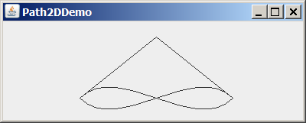
Figure 49.22
You can draw an arbitrary shape using the Path2D class.
The statement new Path2D.Double() (line 15) creates an empty path. The moveTo(100, 100) method (line 16) sets the current pen position at (100, 100). Invoking path.curveTo(150, 50, 250, 150, 300, 100) (line 17) creates a cubic curve from (100, 100) to (300, 100) with control points (150, 50) and (250, 150). Invoking path.moveTo(100, 100) (line 18) moves the pen position back to (100, 100). Invoking path.curveTo(150, 150, 250, 50, 300, 100) (line 19) creates a cubic curve from (100, 100) to (300, 100) with control points (150, 150) and (250, 50). Now the current position is at (300, 100). Invoking path.lineTo(200, 20) (line 20) creates a line from (300, 100) to (200, 20). Invoking path.closePath() (line 21) draws a line connecting the current position (i.e., (200, 20)) with the last moveTo position (i.e., (100, 100)). Finally, Invoking g2d.draw(path) (line 23) draws the path.
For a simple shape, it is easy to decide which point is inside a shape. A path may form many shapes. It is not easy to decide which point is inside an enclosed path. Java 2D uses the winding rules to define the interior points. There are two winding rules: WIND_EVEN_ODD and WIND_NON_ZERO.
<Side remark: WIND_EVEN_ODD>
The WIND_EVEN_ODD rule defines a point as inside a path if a ray from the point toward infinity in an arbitrary direction intersects the path an odd number of times. Consider the path in Figure 49.23a. Points A and C are outside the path, because the ray intersects the path twice. Point B is inside the path, because the ray intersects the path once.
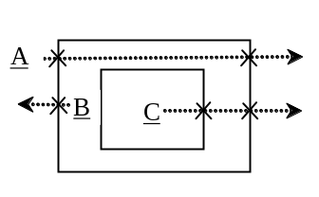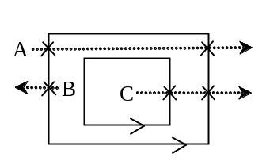
(a) (b)
Figure 49.23
The WIND_EVEN_ODD and WIND_NON_ZERO rules define interior points.
<Side remark: WIND_NON_ZERO>
With the WIND_NON_ZERO rule, the direction of the path is taken into consideration. A point is inside a path if a ray from the point toward infinity in an arbitrary direction intersects the path an unequal number of opposite directions. Consider the path in Figure 49.23(b). Point A is outside the path, because the ray intersects the path twice in opposite directions. Point B is inside the path, because the ray intersects the path once. Point C is inside the path, because the ray intersects the path twice in the same directions. By default, a Path2D is created using the WIND_NON_ZERO rule. You can use the setWindingRule method to set a new winding rule.
Listing 49.9 gives a program that demonstrates winding rules in Path2D. Figure 49.24 shows a sample run of the program.
Listing 49.9 WindingRuleDemo.java
<Side remark: Line 2: import for shape classes>
<Side remark: Line 5: applet>
<Side remark: Line 14: Graphics2D reference>
<Side remark: Line 16: new origin>
<Side remark: Line 17: draw path>
<Side remark: Line 19: new origin>
<Side remark: Line 20: create a path>
<Side remark: Line 21: new winding rule>
<Side remark: Line 22: fill path>
<Side remark: Line 24: new origin>
<Side remark: Line 25: create a path>
<Side remark: Line 26: new winding rule>
<Side remark: Line 27: fill path>
<Side remark: Line 30: create a path>
<Side remark: Line 49: main method omitted>
import java.awt.*;
import java.awt.geom.*;
import javax.swing.*;

public class WindingRuleDemo extends JApplet {
public WindingRuleDemo() {
add(new ShapePanel());
}

class ShapePanel extends JPanel {
protected void paintComponent(Graphics g) {
super.paintComponent(g);

Graphics2D g2d = (Graphics2D)g; // Get Graphics2D

g2d.translate(10, 10); // Translate to a new origin
g2d.draw(createAPath()); // Create and draw a path

g2d.translate(160, 0); // Translate to a new origin
Path2D path2 = createAPath(); // Create a path
path2.setWindingRule(Path2D.WIND_EVEN_ODD); // Set a new rule
g2d.fill(path2); // Create and fill a path

g2d.translate(160, 0); // Translate to a new origin
Path2D path3 = createAPath(); // Create a path
path3.setWindingRule(Path2D.WIND_NON_ZERO); // Set a new rule
g2d.fill(path3); // Create and fill a path
}

private Path2D createAPath() {
// Define the outer rectangle
Path2D path = new Path2D.Double();
path.moveTo(0, 0);
path.lineTo(0, 100);
path.lineTo(100, 100);
path.lineTo(100, 0);
path.lineTo(0, 0);

// Define the inner rectangle
path.moveTo(30, 30);
path.lineTo(30, 70);
path.lineTo(70, 70);
path.lineTo(70, 30);
path.lineTo(30, 30);

return path;
}
}
}

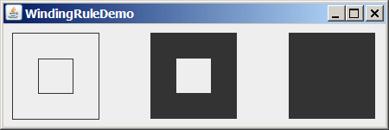
Figure 49.24
The winding rule defines the interior points.
<Side remark: createAPath>
The createAPath() method creates a path for two rectangles. The outer rectangle is created in lines 33–37 and the inner rectangle in lines 40–49.
The program translates the coordinate’s origin to (10, 10) in line 16, invokes createAPath to create a path, and displays it in line 17.
The program translates the coordinate’s origin to (160, 0) in line 19, creates a new path (line 20), sets the path winding rule to WIND_EVEN_ODD (line 21), and displays it in line 22.
The program translates the coordinate’s origin to (160, 0) in line 24, creates a new path (line 25), sets the path winding rule to WIND_NON_ZERO (line 26), and displays it in line 27.
Note that if a path is unclosed, the fill method implicitly closes it and draws a filled path.
49.10 Constructive Area Geometry
Shapes can be combined to create new shapes. This is known as constructive area geometry. Java 2D provides class Area to perform constructive area geometry, as shown in Figure 49.25.
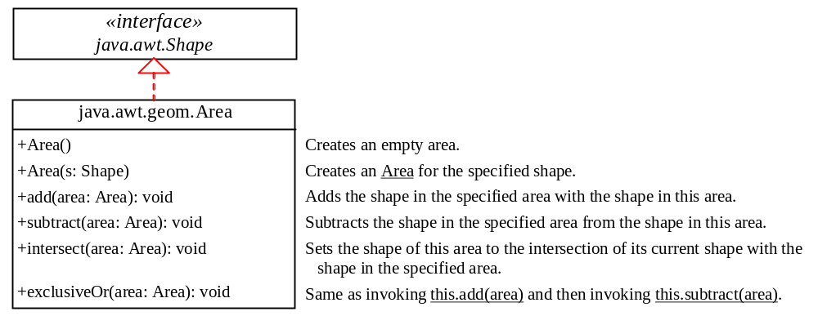
Figure 49.25
The Area class contains the methods for constructing new areas.
Area implements Shape and provides the methods add, subtract, intersect, and exclusiveOr to perform set-theoretic operations union, difference, intersection, and symmetric difference. These operations perform on the shapes stored in the areas. The union of two areas consists of all points that are in either area. The difference of two areas consists of the points that are in the first area, but not in the second area. The intersection of two areas consists of all points that are in both areas. The symmetric difference consists of the points that are in exactly one of the two areas.
Listing 49.10 gives a program that demonstrates constructive geometry using the Area class. Figure 49.26 shows a sample run of the program.
Listing 49.10 AreaDemo.java
<Side remark: Line 2: import for shape classes>
<Side remark: Line 5: applet>
<Side remark: Line 14: Graphics2D reference>
<Side remark: Line 17: two shapes>
<Side remark: Line 19: new origin>
<Side remark: Line 23: draw shapes>
<Side remark: Line 25: add>
<Side remark: Line 30: fill area>
<Side remark: Line 33: subtract>
<Side remark: Line 35: fill area>
<Side remark: Line 38: intersect>
<Side remark: Line 40: fill area>
<Side remark: Line 42: exclusiveOr>
<Side remark: Line 43: fill area>
<Side remark: Line 48: main method omitted>
import java.awt.*;
import java.awt.geom.*;
import javax.swing.*;

public class AreaDemo extends JApplet {
public AreaDemo() {
add(new ShapePanel());
}

class ShapePanel extends JPanel {
protected void paintComponent(Graphics g) {
super.paintComponent(g);

Graphics2D g2d = (Graphics2D)g; // Get Graphics2D

// Create two shapes
Shape shape1 = new Ellipse2D.Double(0, 0, 50, 50);
Shape shape2 = new Ellipse2D.Double(25, 0, 50, 50);
g2d.translate(10, 10); // Translate to a new origin
g2d.draw(shape1); // Draw the shape
g2d.draw(shape2); // Draw the shape

Area area1 = new Area(shape1); // Create an area
Area area2 = new Area(shape2);
area1.add(area2); // Add area2 to area1
g2d.translate(100, 0); // Translate to a new origin
g2d.draw(area1); // Draw the outline of the shape in the area

g2d.translate(100, 0); // Translate to a new origin
g2d.fill(area1); // Fill the shape in the area

area1 = new Area(shape1);
area1.subtract(area2); // Subtract area2 from area1
g2d.translate(100, 0); // Translate to a new origin
g2d.fill(area1); // Fill the shape in the area

area1 = new Area(shape1);
area1.intersect(area2); // Intersection of area2 with area1
g2d.translate(100, 0); // Translate to a new origin
g2d.fill(area1); // Fill the shape in the area

area1 = new Area(shape1);
area1.exclusiveOr(area2); // Exclusive or of area2 with area1
g2d.translate(100, 0); // Translate to a new origin
g2d.fill(area1); // Fill the shape in the area
}
}
}

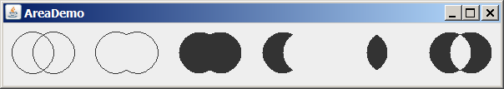
Figure 49.26
The Area class can be used to perform constructive geometry.
The program creates two ellipses (lines 17–18) and displays them (lines 20–21). The program creates two areas and invokes add (line 25), subtract (line 33), intersect (line 38), and exclusiveOr (line 43) to perform constructive area geometry.
Key Terms
- constructive area geometry
- cubic curves
- gradient paint
- quadratic curves
- rotation
- scaling
- stroke
- texture paint
- translation
- WIND_EVEN_ODD
- WIND_NON_ZERO

Chapter Summary

- The Java 2D API provides the java.awt.Graphics2D class, which extends java.awt.Graphics with advanced capabilities for rendering graphics.
- The Java 2D API provides an object-oriented approach that separates rendering from modeling. All shapes are defined under the Shape interface.
- Classes Line2D, Rectangle2D, RoundRectangle2D, Arc2D, Ellipses2D, QuadCurve2D, CubicCurve2D, and Path2D are abstract classes. Each contains two concrete static inner classes named Double and Float for double and float coordinates, respectively. The inner classes are subclasses of their respective abstract classes.
- A point can be modeled using the abstract Point2D class. It contains two concrete static inner classes Point2D.Double and Point2D.Float, which are subclasses of Point2D.
- The Graphics2D class is for rendering shapes. You can invoke its draw(Shape) method to render the boundary of the shape and fill(Shape) method to fill the interior of the shape.
- You can use the translate(double x, double y) method in the Graphics class to move the subsequent rendering by the specified distance relative to the previous position.
- You can use the rotate(double theta) method in the Graphics2D class to rotate subsequent rendering by theta degrees from the origin, where theta is a double value in radians.
- You can use the scale(double sx, double sy) method in the Graphics2D class to resize subsequent rendering by the specified scaling factors.
- Java 2D allows you to specify the attributes of lines, called strokes.
- You can specify the width of the line, how the line ends (called end caps), how lines join together (called line joins), and whether the line is dashed. These attributes are defined in a Stroke object.
- You can create a Stroke object using the BasicStroke class.
- To set a stroke, use the setStroke(Stroke) method in the Graphics2D class.
- Graphics2D provides the setPaint(Paint) method to set a paint. Paint is a generalization of color. It has more attributes than simple solid colors.
- GradientPaint defines a varying color, specified by two points and two colors. As the location moves from the first point to the second, the paint changes gradually from the first color to the second.
- A GradientPaint can cyclic or acyclic. A cyclic paint repeats the same pattern periodically.
- TexturePaint defines an image to fill a shape or characters. A texture paint is defined by an image anchored in a rectangle.
- Java 2D provides the QuadCurve2D and CubicCurve2D classes for modeling quadratic curves and cubic curves.
- A quadratic curve is mathematically defined as a quadratic polynomial.
- A cubic curve is mathematically defined as a cubic polynomial.
- The Path2D class models an arbitrary geometric path. Path2D.Double and Path 2D.Float are two concrete subclasses of Path 2D.
- The winding rule defines interior points in a path.
- The WIND_EVEN_ODD rule defines a point as inside a path if a ray from the point toward infinity in an arbitrary direction intersects the path an odd number of times.
- With the WIND_NON_ZERO rule, the direction of the path is taken into consideration. A point is inside a path if a ray from the point toward infinity in an arbitrary direction intersects the path an unequal number of opposite directions.
- Java 2D provides class Area to perform constructive area geometry.
- Area implements Shape and provides the methods add, subtract, intersect, and exclusiveOr to perform set-theoretic operations union, difference, intersection, and symmetric difference.

Test Questions
Do the test questions for this chapter online at www.cs.armstrong.edu/liang/intro9e/test.html.

Review Questions
Sections 49.2–49.3
49.1 How do you obtain a reference to a Graphics2D object?

49.2 List some methods defined in the Shape interface.

49.3 How do you create a Line2D object?

49.4 Are Line2D.Double and Line2D.Float inner classes of Line2D? Are they also subclasses of Line2D?

49.5 How do you render a Shape object?

49.6 What are the relationships among Point2D, Point2D.Double, Point2D.Float, and Point? Check Java API to see what methods are defined in Point2D.

Section 49.4
49.7 What are the relationships among Rectangle2D, Rectangle2D.Double, Rectangle2D.Float, and Rectangle?

49.8 You can draw basic shapes such as lines, rectangles, ellipses, and arcs using the drawing/filling methods in the Graphics class or create a Shape object and render them using the draw(Shape) or fill(Shape). What are the advantages of using the latter?

Section 49.5
49.9 Suppose a rectangle is created using new Rectangle2D.Double(2, 3, 4, 5). Where is it displayed after applying g2d.translate(10, 10) and g2d.draw(rectangle)?

49.10 Suppose a rectangle is created using new Rectangle2D.Double(2, 3, 4, 5). Where is it displayed after applying g2d.rotate(Math.PI / 5) and g2d.draw(rectangle)?

49.11 Suppose a rectangle is created using new Rectangle2D.Double(2, 3, 4, 5). Where is it displayed after applying g2d.scale(10, 10) and g2d.draw(rectangle)?

Sections 49.6–49.7
49.12 How do you create a Stroke and set a stroke in Graphics2D?

49.13 How do you create a Paint and set a paint in Graphics2D?

49.14 What is a gradient paint? How do you create a GradientPaint?

49.15 What is a texture paint? How do you create a TexturePaint?

Sections 49.8–49.10
49.16 How do you create a QuadCurve2D? How do you create a CubicCurve2D?

49.17 Describe the methods in Path2D?

49.18 What is the winding rule? What is WIND_EVEN_ODD? What is WIND_NON_ZERO?

49.19 How do you create an Area from a shape? Describe the add, subtract, intersect, and exclusiveOr methods in the Area class.

Programming Exercises
Section 49.4
49.1*
(Inside a rectangle?) Write a program that displays a rectangle with upper-left corner point at (20, 20), width 100, and height 100. Whenever you move the mouse, display a message indicating whether the mouse point is inside the rectangle, as shown in Figure 49.27a–b.

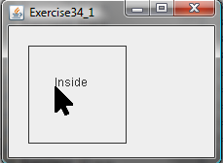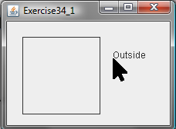
(a) (b)
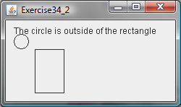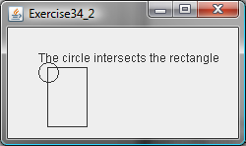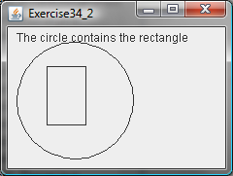
(c) (d) (e)
Figure 49.27
(a-b) Exercise 49.1 detects whether a point is inside a rectangle. (c-e) Exercise 49.2 detects whether a circle contains, intersects, or is outside a rectangle.
49.2*
(Contains, intersects, or outside?) Write a program that displays a rectangle with upper-left corner point at (40, 40), width 40, and height 60. Display a circle. The circle’s upper-left corner of the bounding rectangle is at the mouse point. pressing the up/down arrow key increases/decreases the circle radius by 5 pixels by. Display a message at the mouse point to indicate whether the circle contains, intersects, or is outside of the rectangle, as shown in Figure 49.27c-e.

49.3*
(Translation) Write a program that displays a rectangle with upper-left corner point at (40, 40), width 50, and height 40. Enter the values in the text fields x and y and press the Translate button to translate the rectangle to a new location, as shown in Figure 49.28a.

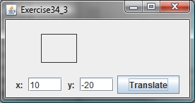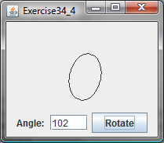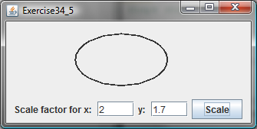
(a) (b) (c)
Figure 49.28
(a) Exercise 49.3 translates coordinates. (b) Exercise 49.4 rotates coordinates. (c) Exercise 49.5 scales coordinates.
49.4*
(Rotation) Write a program that displays an ellipse. The center of the ellipse is at (0, 0) with width 60 and height 40. Use the translate method to move the origin to (100, 70). Enter the value in the text field Angle and press the Rotate button to rotate the ellipse to a new location, as shown in Figure 49.28b.

49.5*
(Scale graphics) Write a program that displays an ellipse. The center of the ellipse is at (0, 0) with width 60 and height 40. Use the translate method to move the origin to (150, 50). Enter the scaling factors in the text fields and press the Scale button to scale the ellipse, as shown in Figure 49.28c.

49.6*
(Vertical strings) Write a program that displays three strings vertically, as shown in Figure 49.29a.

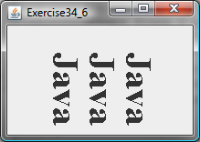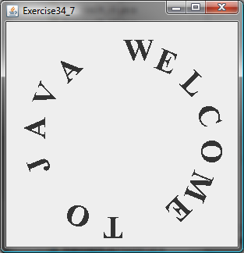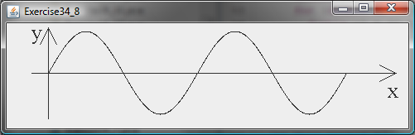
(a) (b) (c)
Figure 49.29
(a) Exercise 49.6 displays strings vertically. (b) Exercise 49.7 displays characters around the circle. (c) Exercise 49.8 displays a sine function.
49.7*
(Characters around circle) Write a program that displays a string around the circle, as shown in Figure 49.29b.

49.8*
(Plot the sine function) Write a program that plots the sine function, as shown in Figure 49.29c.

49.9*
(Plot the log function) Write a program that plots the log function, as shown in Figure 49.30a.

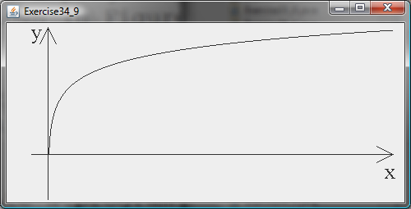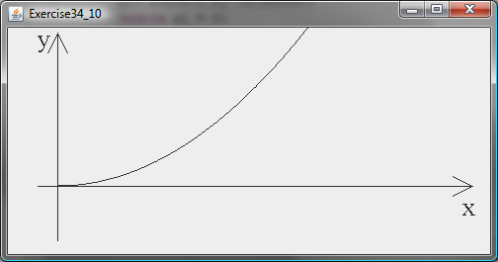
(a) (b)
Figure 49.30
(a) Exercise 49.9 displays the log function. (b) Exercise 49.10 displays the n² function.
49.10*
(Plot the n² function) Write a program that plots the n² function, as shown in Figure 49.30b.

49.11*
(Plot the log, n, nlogn, and n² functions) Write a program that plots the log, n, nlogn, and n² functions, as shown in Figure 49.31a.

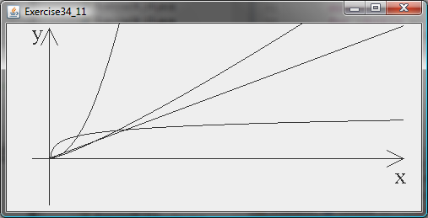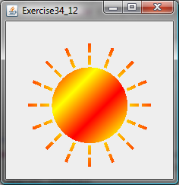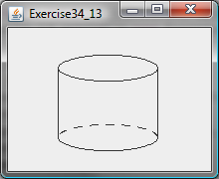
(a) (b) (c)
Figure 49.31
(a) Exercise 49.11 displays several functions. (b) Exercise 49.12 displays the sunshine. (c) Exercise 49.13 displays a cylinder.
49.12*
(Sunshine) Write a program that displays a circle filled with a gradient color to animate a sun and display light rays coming out from the sun using dashed lines, as shown in Figure 49.31b.

49.13*
(Display a cylinder) Write a program that displays a cylinder, as shown in Figure 49.31c. Use dashed strokes to draw the dashed arc.

49.14*
(Filled cylinder) Write a program that displays a filled cylinder, as shown in Figure 49.32a.

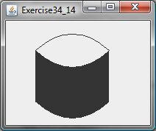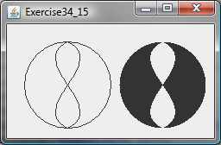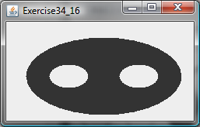
(a) (b) (c)
Figure 49.32
(a) Exercise 49.14 displays a filled cylinder. (b) Exercise 49.15 displays symmetric difference of two areas. (c) Exercise 49.16 displays two eyes.
49.15*
(Area geometry) Write a program that creates two areas: a circle and a path consisting of two cubic curves. Draw the areas and fill the symmetric difference of the areas, as shown in Figure 49.32(b).

49.16*
(Eyes) Write a program that displays two eyes in an oval, as shown in Figure 49.32c.

49.17**
(Geometry: strategic point of a polygon) Revise Exercise 14.33 to enable the user to drag and move the vertices and the program dynamically redisplay the polygon and its strategic point. Write a program as an applet and assume the five points of the polygon are initially located at (25, 20), (170, 25), (200, 100), (100, 110), and (50, 80).
49.18*
(Scale and rotate graphics) Write an applet that enables the user to scale and rotate the STOP sign, as shown in Figure 49.33. The user can press the CTRL and +/- key to increase/decrease the size and press the RIGHT/LEFT arrow key to rotate left or right.
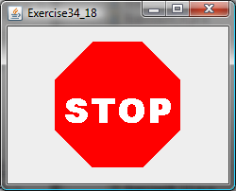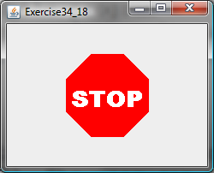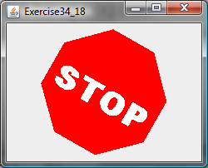

Figure 49.33
The applet can scale and rotate the painting.

